# EMI functionality

# Scope

The scope of this document is to cover the rules of EMI facility provided to customer on LATAM websites.

# Rules:

1. Payment in EMI’s option will only be available to user when his travel date is exactly 3 months after the date on which he is making booking.
2. The range of EMI’s will be between 4 and 10. The range of EMI’s will be decided by the system depending upon user’s selection of travel dates.
3. The first EMI will be paid by the customer at the time of making booking.
4. The total number of EMI’s will be calculated as per formula:

Number of EMI’s=Total number of months after which travel date is selected + 1;

For example:

Date on which booking is being made is 26 Aug 2015 and travel date is 7 Jan 2016 than total number of complete months are 4 and putting it in formula we get 5 EMI’s.

The dates on which user has to pay EMI’s are as follows:

1st EMI=26 Aug 2015

2nd EMI=26 Sep 2015

3rd EMI=26 Oct 2015

4th EMI= 26 Nov 2015

5th EMI=17 Dec 2015

You may observe that the last date of paying EMI is 17 Dec, 2015 this is because the last EMI should be paid before 21 days (3 Weeks) of travel date.

1. The maximum EMI which system displays is 10. If user selects a travel date after 10 months than also total number of EMI’s rendered by system will be 10.

Considering the same example again if customer’s booking date is 26 Aug 2015 and he selects travel date is 28 July 2016 in this case system will display only 10 EMI’s.

1. The total booking value is divided by the number of EMI’s to calculate the value of each EMI.

For example if booking value is US$ 659 and total number of EMI’s are 10 than each EMI will be:

659/10=65.9

But we have an exception here:

If value of each EMI is not a whole number which is not in above case than the first EMI will be bigger than rest of the EMI’s

In above case EMI’s will be distributed as below:

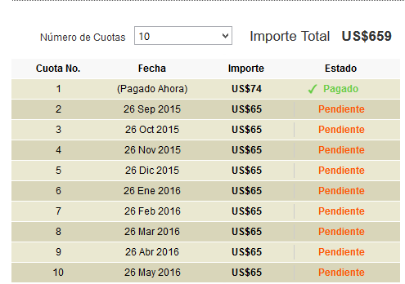

The first EMI will be calculated by system by following formula:

First EMI=value before decimal +value after decimal*(number of EMI’s);

Putting the above in formula:

First EMI=65+0.9*(10);

First EMI=74;

1. In case of payment in EMI’s the reminder email will be sent by scheduler to customer’s email address before 4 days the date on which he has to pay his installment.
2. The final voucher of tour will be sent to customer’s email address after 48 hours of payment of last EMI.